1.9.1-CD SearchController Class Diagram
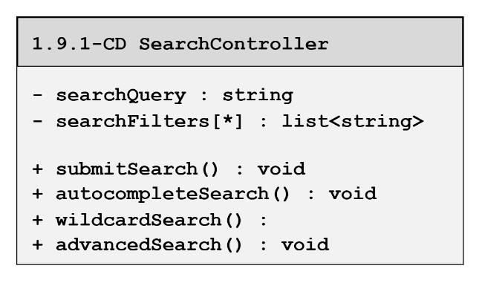
1.9.2-CD CandaditeSearch Class Diagram
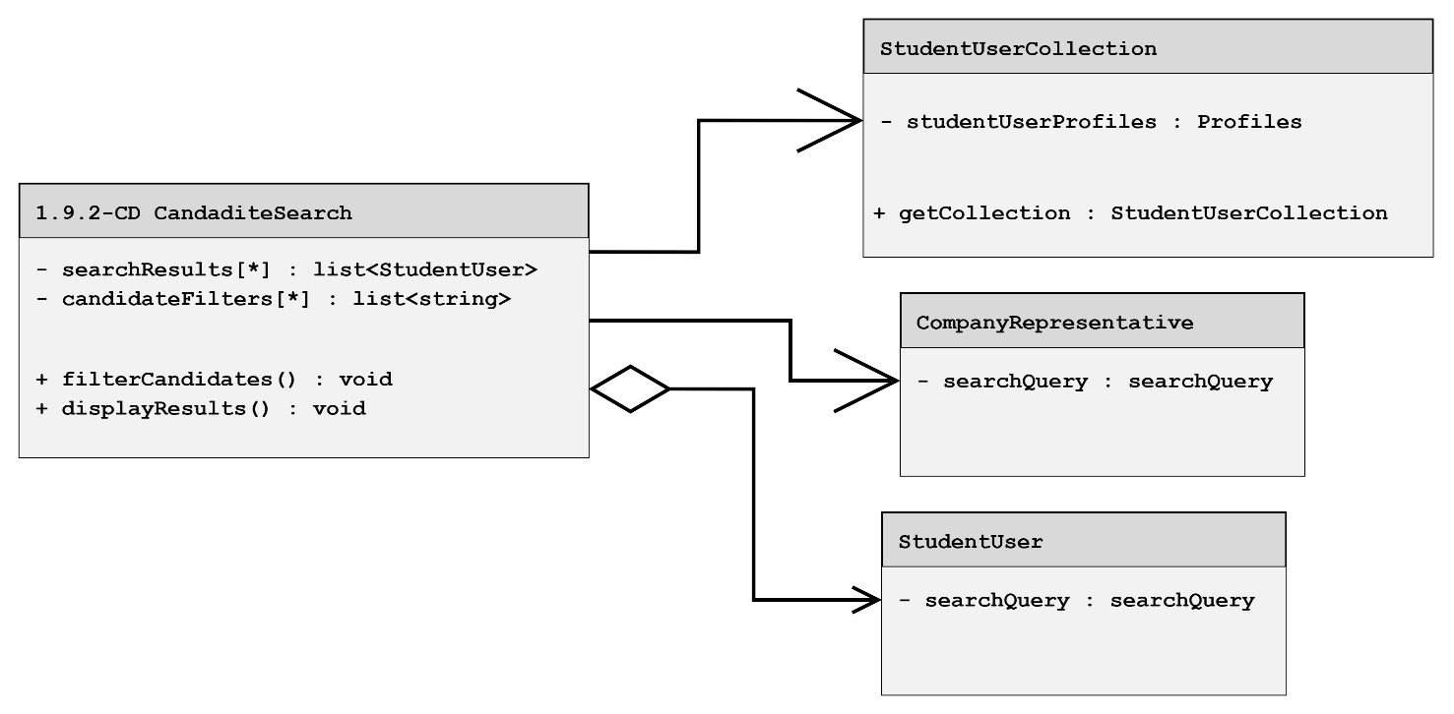

1.9.3-CD SearchController Class Diagram
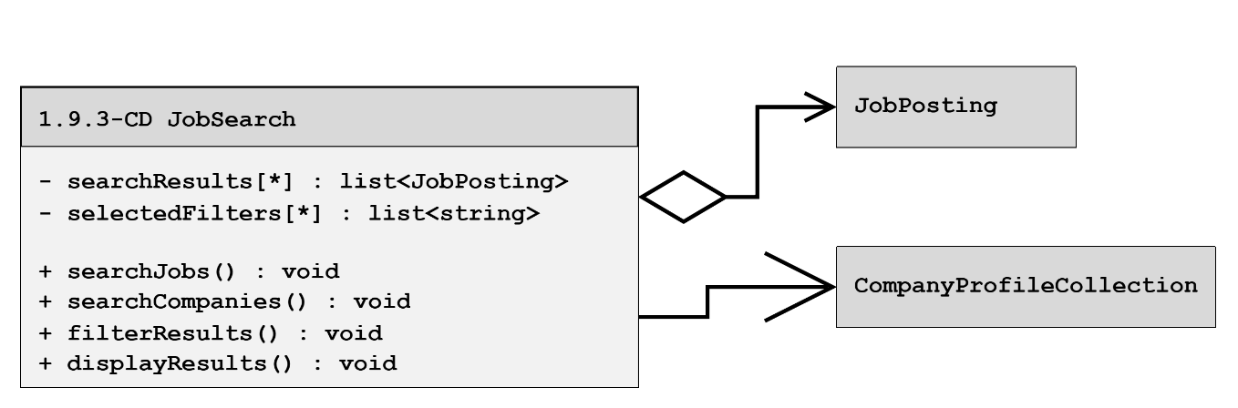

1.9.4-6-CD SearchController Class Diagram
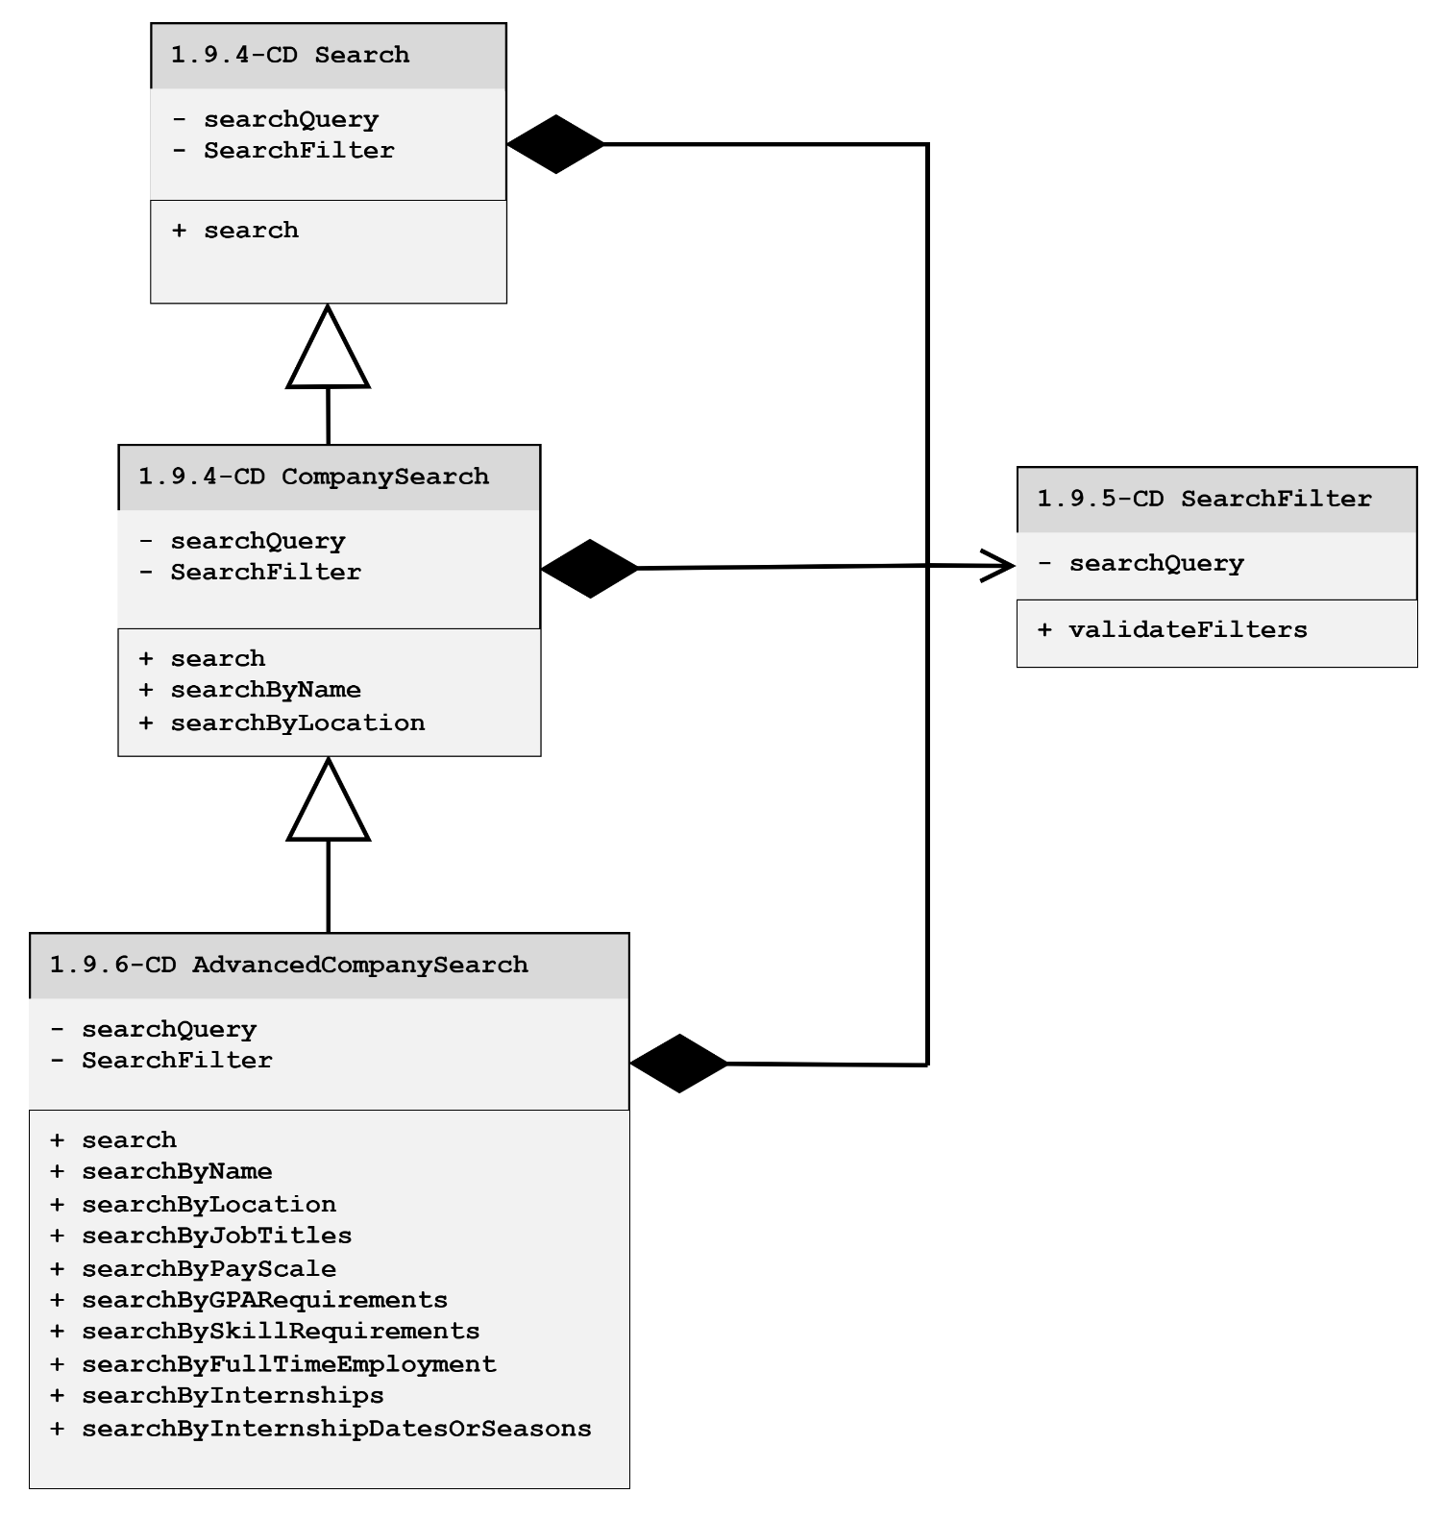
1.9.7-9-CD SearchController Class Diagram
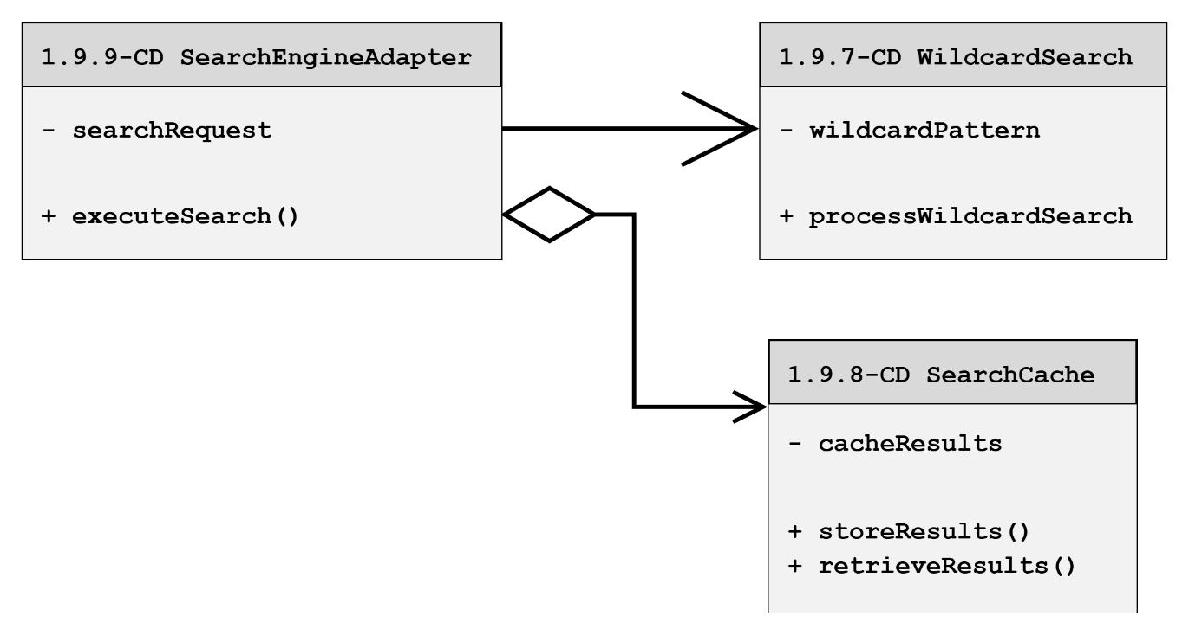

1.9.10-CD SearchController Class Diagram
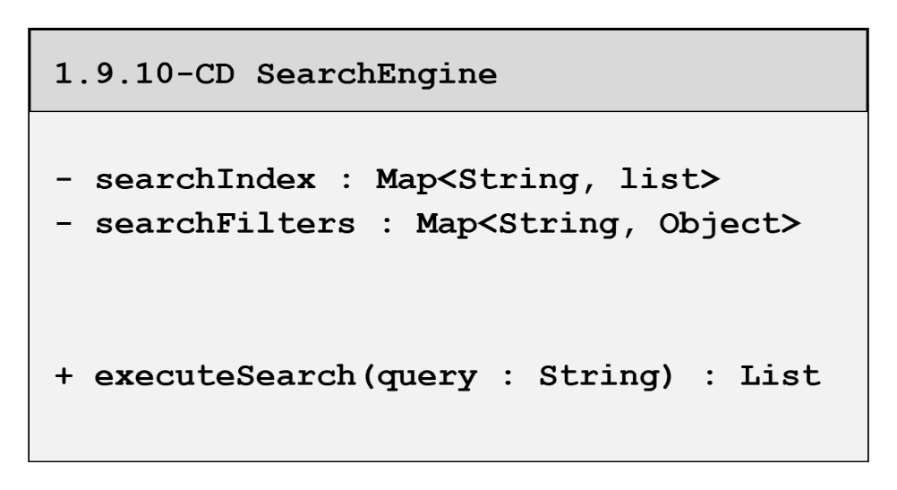

1.9.11-CD SearchController Class Diagram
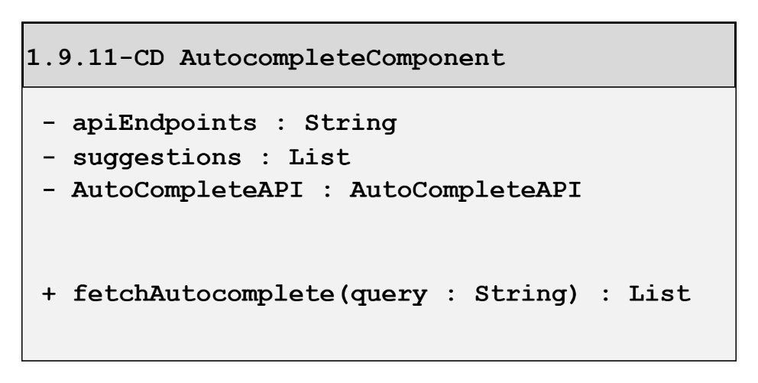

1.9.12-CD SearchController Class Diagram
